**Figures**

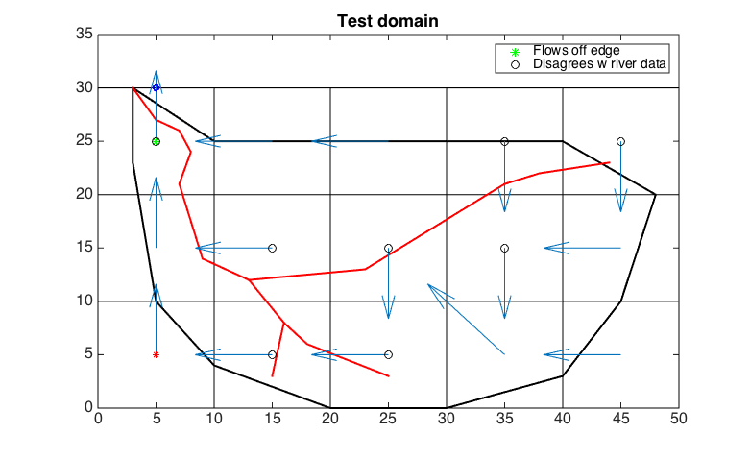

Figure 1. Flow direction map (made-up example). Basin boundary is shown in black. Blue arrows show flow directions (calculated from a DEM). Red lines show the true river network. Black circles show where the flow directions "disagree" with the direction of the true river network.

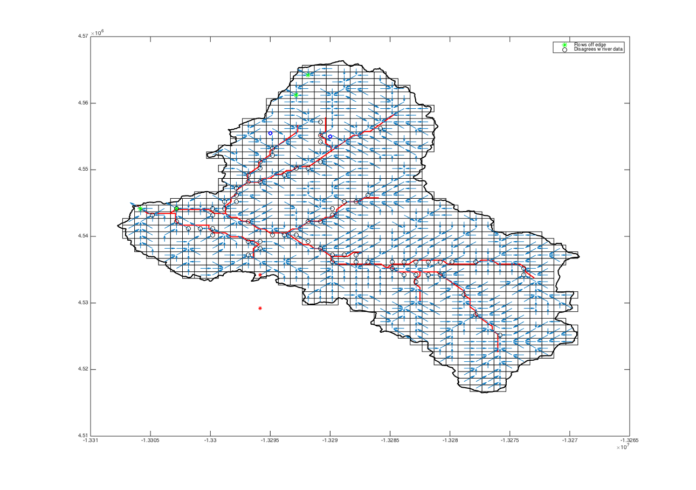Figure 2. Upper Tuolumne River Basin. Flow directions and river centerlines upstream of the Hetch Hetchy Reservoir. Blue markers are gauge locations.

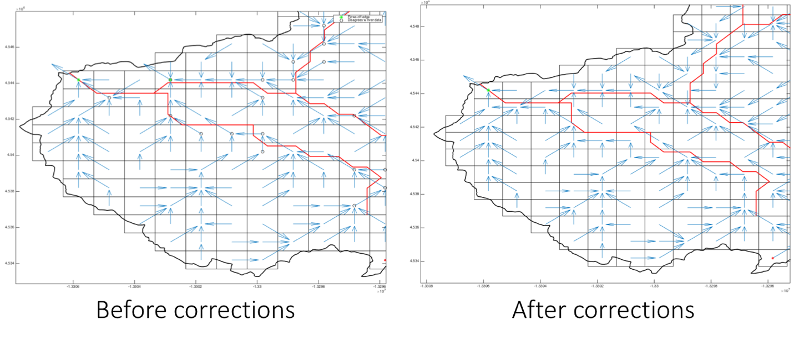

Figure 3. Zoomed-in view of the Upper Tuolumne River Basin, near the outlet. Flow directions and river centerlines upstream of the Hetch Hetchy Reservoir. Blue markers are gauge locations.

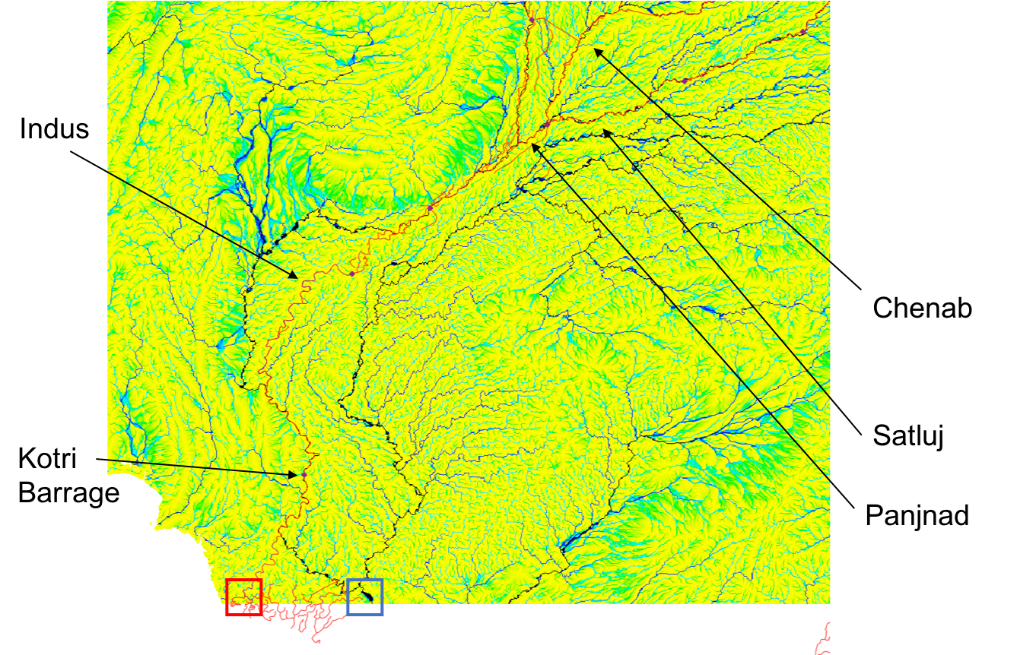

Figure 4. Finding the outlet of the IRB. Map shows the 30 arc-second flow accumulation map and the GRWL median flow centerlines. The true outlet is boxed in red, while the location of highest flow accumulation is boxed in blue.

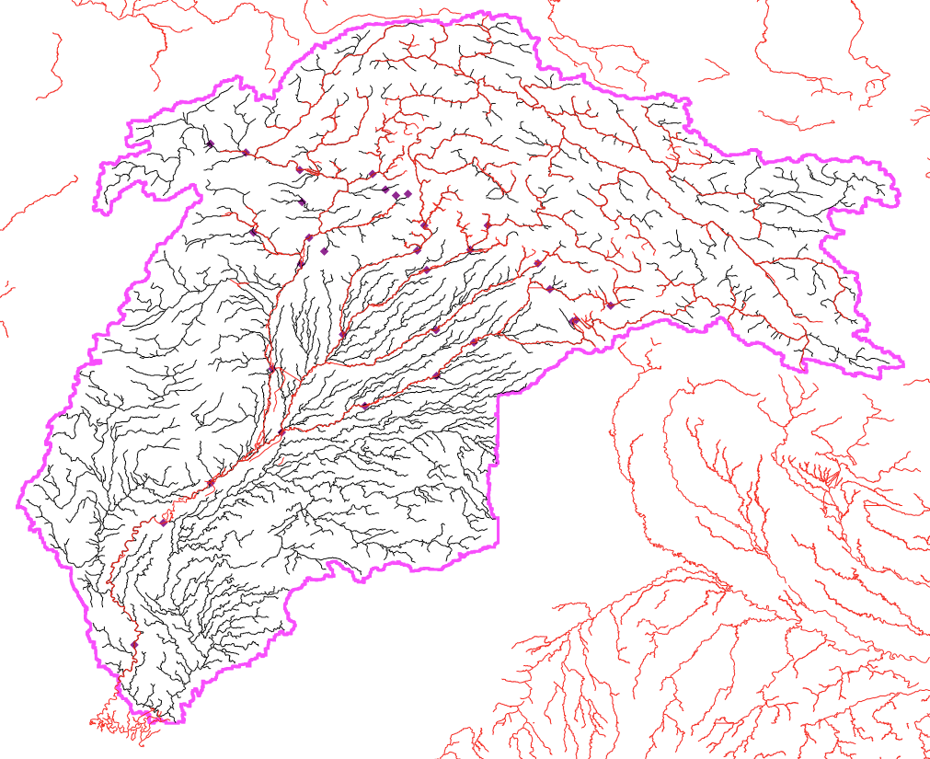

Figure 5. Indus Basin delineated from 30 arc-second DEM. Black lines show the delineated channels, red lines the GRWL dataset. Dams are shown as purple diamonds.

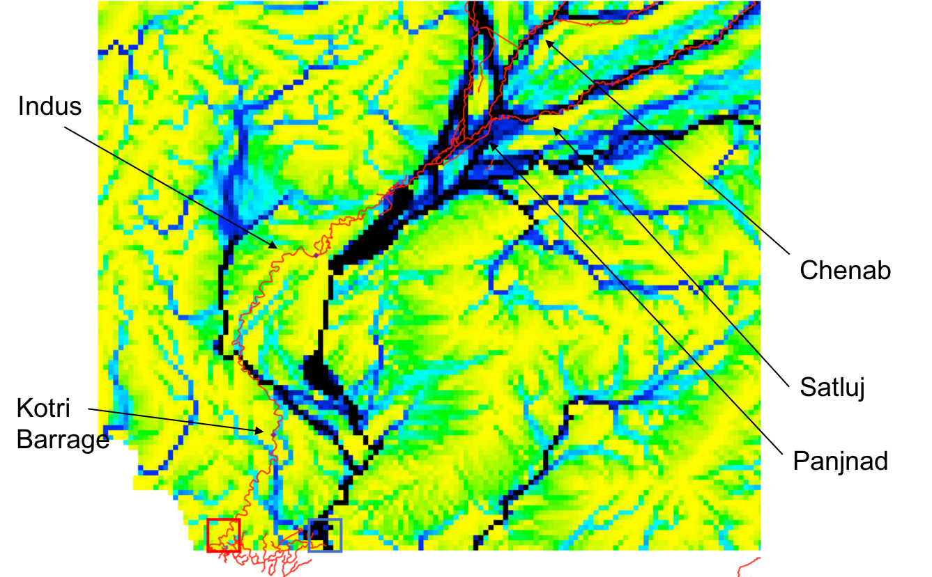

Figure 6. As Figure 4, but at 1/16 degree resolution.

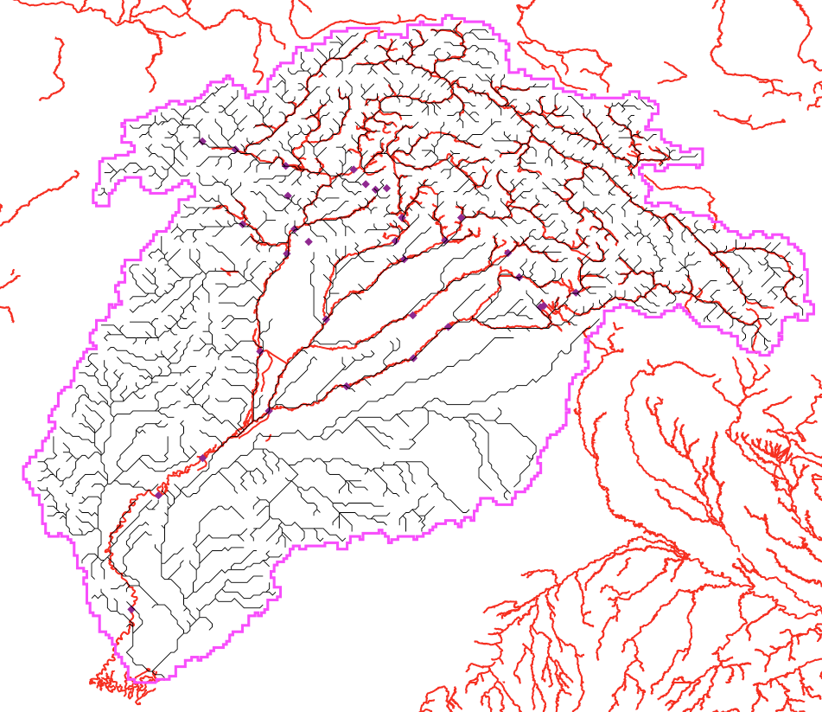

Figure 7. As Figure 5, but at 1/16 degree resolution.

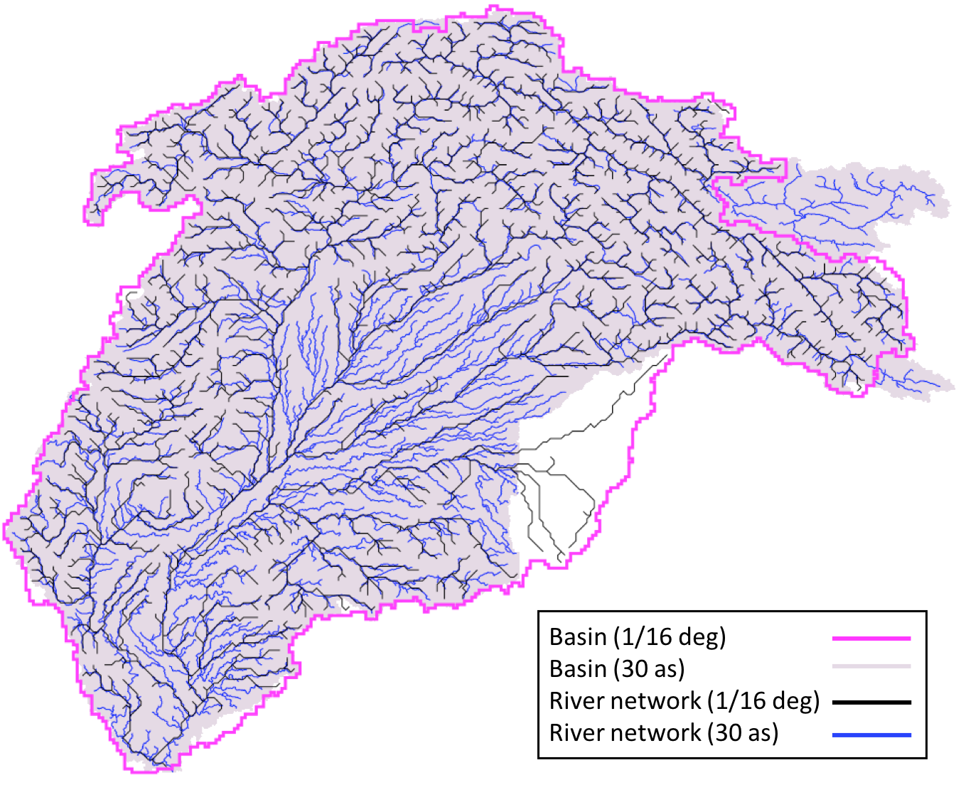

Figure 8. Comparing the two basins delineated at different resolutions.

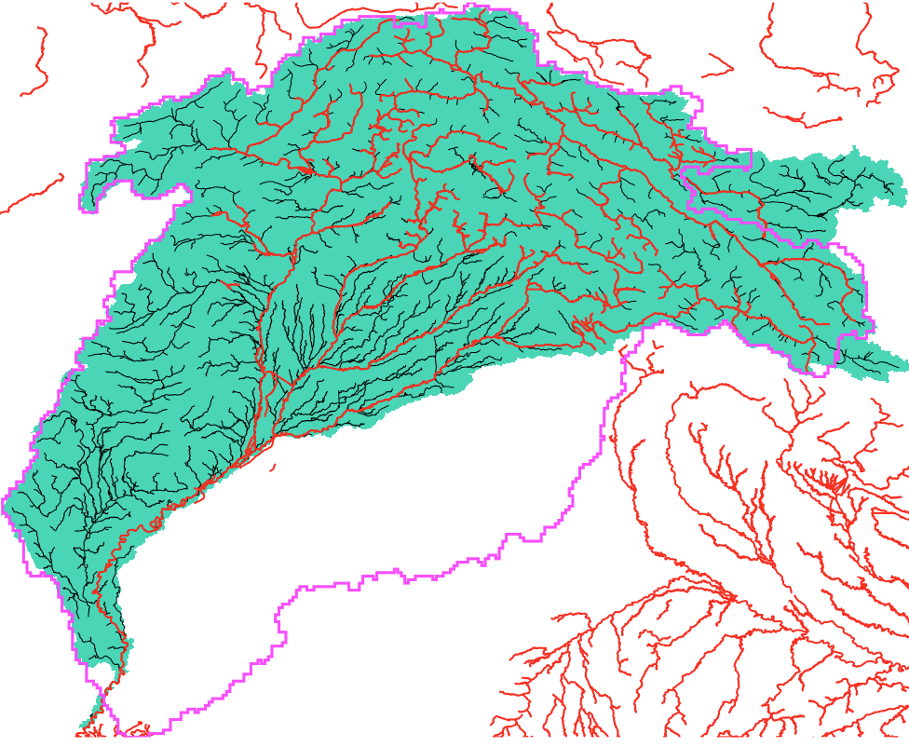

Figure 9. Indus River Basin delineated from 3-arc second MERIT hydrologically-conditioned DEM. Red lines are the GRWL centerlines, magenta line is IRB basin outline delineated from the 1/16 degree DEM. Black lines and green shaded area are the river network and basin area derived from the 3 arc-second MERIT hydrography data. The upper right-hand portion of the basin is not correct/does not match the Khan et al. (2014) paper, so it is not entirely accurate.

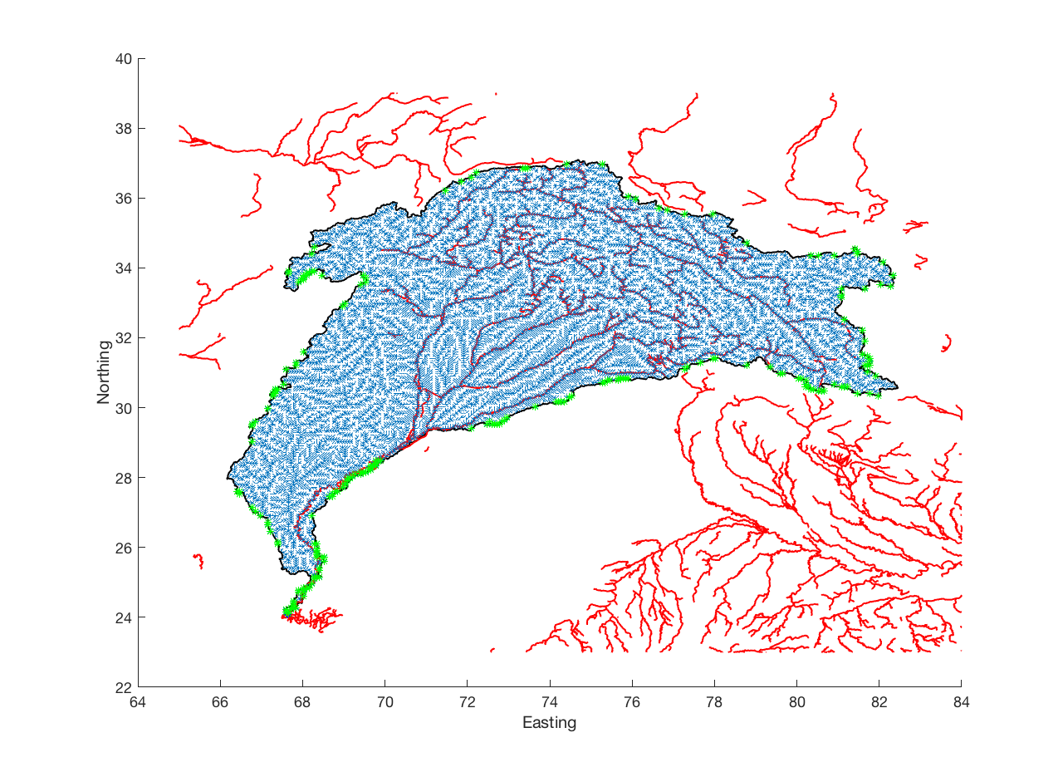

Figure 10. Indus River Basin delineated from 1/16 degree upscaled MERIT DEM. It needs manual corrections to be a better match with the true basin. Green markers show where the coarse flow directions leave the true basin (delineated from 3 arc-second DEM).